Monitor E-sports Chat with Streamlit
experimentLabschedule50 minutesuniversal_currency_altNo costshow_chartIntroductory
infoThis lab may incorporate AI tools to support your learning.

GSP1343

Overview
Imagine you are a data engineer for Cymbal Gaming. You and the development team are building a new e-sports game, "Galactic Grand Prix." The game produces real-time data from heads-up matches between two players from different teams, where a winner is determined and points are awarded to the winning player and team. The game also supports in-game chat so that players can communicate with teammates. Although players are aware of the End User License Agreement, they may occasionally act unsportsmanlike, especially during intense matches, which is reflected in chat messages. You have been tasked with creating a solution for moderators to monitor and take action on chat messages that break the terms of the end user license agreement.
You have explored Pub/Sub, BigQuery, Bigtable, and the Streamlit Framework (Python), identifying them as potential tools for this use case. You have also learned that Gemini can help you with the build. For example, if you get stuck with writing a new query you could use it for help. However, you are not sure how to get started.
When you start the lab, the following resources and files are provided to you.
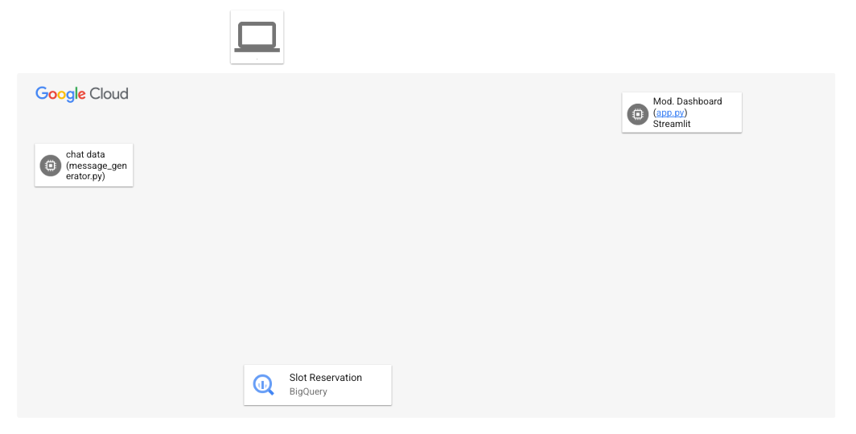
By the end of the lab, you will have used the architecture to perform several tasks.
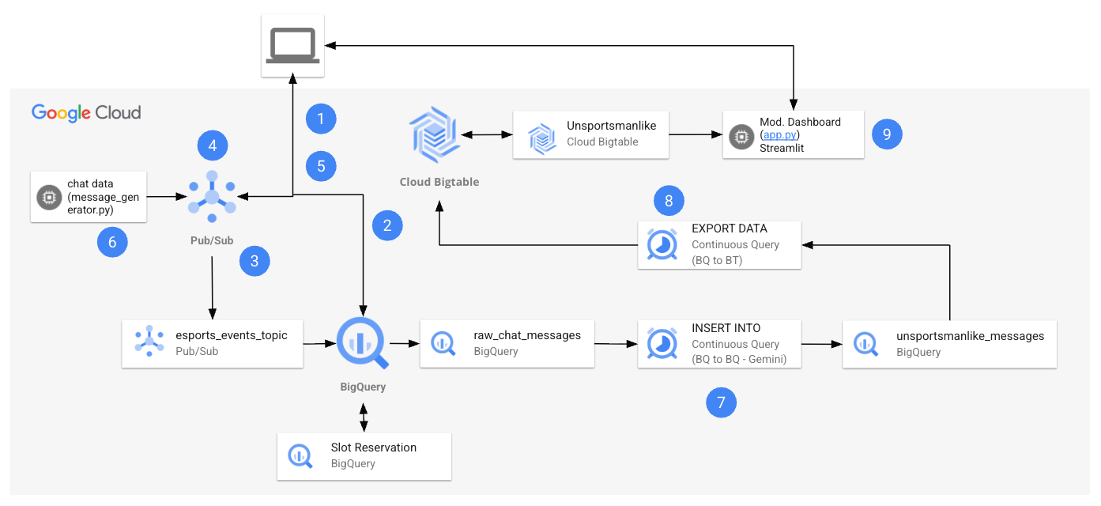
The following table provides a detailed explanation of each task in relation to the lab architecture.
Numbered Task | Detail
1. | Configure environment variables in Cloud Shell.
2. | Create the Cloud resources:  You will use Cloud Shell commands to create the BigQuery dataset and table, and the Bigtable instance and table.
3. | Create the Pub/Sub Topic and Subscription:  You will use the Pub/Sub console to create the topic and subscription, and modify the subscription so that it can write to your BigQuery dataset and table.
4. | Grant Pub/Sub IAM permissions:  You will use the IAM console to grant permissions to the compute service account.
5. | Retrieve the Python files from the repo:  In this task, you retrieve the Python files from the repo, and configure the message_generator.py file for your project.
6. | Generate synthetic data  With the file modified, you will then run the file. The file uses Python to generate continuous Pub/Sub messages for player chat.
7. | Create the BigQuery ML Remote Model:  . In this task, you create a Vertex AI remote model connection to Gemini with a service account, and then use it to build your model in BigQuery.
8. | Run a continuous query to analyze chat messages:  Now that you have sent the data to your Pub/Sub topic, your data is being captured and stored in your BigQuery table. You will run a query on the table to confirm messages are stored. Once you have confirmation the data is stored, you will create a continuous query in BigQuery using Gemini-based model to analyze each chat message as unsportsmanlike or sportsmanlike. You will then use a separate continuous query to send the unsportsmanlike chats to Bigtable.
9. | Monitor messages with your Streamlit application:  Now that the unsportsmanlike messages are filtered and sent to Bigtable, you will use your Streamlit application to monitor the messages and take action.

Objectives
In this lab, you learn how to:
- Create the cloud resources and grant access to them.
- Retrieve Python files from the repo and review them.
- Generate synthetic data.
- Create the BigQuery ML Remote Model.
- Filter unsportsmanlike messages and build your continuous queries.
- Monitor messages with a Streamlit application.
Finally, you will reflect on your learning and consider how to apply streaming data solutions to your own use cases by answering questions in your Lab Journal.

Setup and requirements

Before you click the Start Lab button
Read these instructions. Labs are timed and you cannot pause them. The timer, which starts when you click Start Lab, shows how long Google Cloud resources are made available to you.
This hands-on lab lets you do the lab activities in a real cloud environment, not in a simulation or demo environment. It does so by giving you new, temporary credentials you use to sign in and access Google Cloud for the duration of the lab.
To complete this lab, you need:
- Access to a standard internet browser (Chrome browser recommended).
Note: Use an Incognito (recommended) or private browser window to run this lab. This prevents conflicts between your personal account and the student account, which may cause extra charges incurred to your personal account.
- Time to complete the lab—remember, once you start, you cannot pause a lab.
Note: Use only the student account for this lab. If you use a different Google Cloud account, you may incur charges to that account.

How to start your lab and sign in to the Google Cloud console
- Click the Start Lab button. If you need to pay for the lab, a dialog opens for you to select your payment method. On the left is the Lab Details pane with the following:
  - The Open Google Cloud console button
  - Time remaining
  - The temporary credentials that you must use for this lab
  - Other information, if needed, to step through this lab
- Click Open Google Cloud console (or right-click and select Open Link in Incognito Window if you are running the Chrome browser).
The lab spins up resources, and then opens another tab that shows the Sign in page.
Tip: Arrange the tabs in separate windows, side-by-side.
- Note: If you see the Choose an account dialog, click Use Another Account.
- If necessary, copy the Username below and paste it into the Sign in dialog.
- "Username"
- Copied!
- You can also find the Username in the Lab Details pane.
- Click Next.
- Copy the Password below and paste it into the Welcome dialog.
- "Password"
- Copied!
- You can also find the Password in the Lab Details pane.
- Click Next.
- Important: You must use the credentials the lab provides you. Do not use your Google Cloud account credentials.
- Note: Using your own Google Cloud account for this lab may incur extra charges.
- Click through the subsequent pages:
  - Accept the terms and conditions.
  - Do not add recovery options or two-factor authentication (because this is a temporary account).
  - Do not sign up for free trials.
After a few moments, the Google Cloud console opens in this tab.
Note: To access Google Cloud products and services, click the Navigation menu or type the service or product name in the Search field. 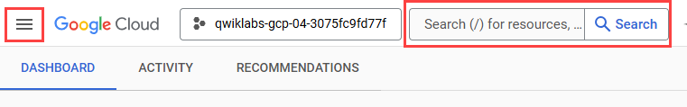

Task 1. Configure environment variables in Cloud Shell
In this task, you configure environment variables in Cloud Shell.
- Open Cloud Shell, by clicking Activate Cloud Shell.
- Authorize use of Cloud Shell, if prompted, by clicking Continue and then Authorize in the pop-up windows.
- Run the following command.
- gcloud config set project set at lab start
- Copied!
- Run the following commands.
export GCP_PROJECT_ID="Project ID"
export GCP_REGION="Region"
export BUCKET_NAME="Project ID-bucket"
- export GEMINI_MODEL_ID="model_name"
- Copied!
- Run the commands below to confirm the variables are stored.
echo ${GCP_PROJECT_ID}
echo ${GCP_REGION}
echo ${BUCKET_NAME}
- echo ${GEMINI_MODEL_ID}
- Copied!
- You will use these variables later in the lab.

Task 2. Create the cloud resources
In this task, you will create the BigQuery Dataset and table that will receive the raw streaming events from Pub/Sub. You will also create the unsportsmanlike BigQuery table. Finally, you will create the Bigtable instance and table, which will be used with your Streamlit application.

Create the BigQuery dataset
In this task, you will create the BigQuery dataset that will act as a container for your tables and views.
- Run the following command to create the BigQuery dataset.
- bq mk --location=Region esports_analytics
- Copied!
You see a confirmation message indicating the new esports_analytics dataset is created. This confirms you have successfully created the dataset.

Create the BigQuery raw_chat_messages table
In this task you will create the raw_chat_messages table within the esports_analytics dataset you just created.
- Run the following command to create the BigQuery table.
bq mk --table esports_analytics.raw_chat_messages \
- message_id:STRING,user_id:STRING,timestamp:TIMESTAMP,message_text:STRING,game_id:STRING,server_region:STRING
- Copied!
A confirmation message indicates the raw_chat_messages table is created in the esports_analytics dataset.

Create the BigQuery unsportsmanlike_messages table
In this task, you will create the unsportsmanlike_messages table within esports_analytics dataset you just created.
- Run the following command to create the BigQuery table.
bq mk \
--table \
--description "Table to store unsportsmanlike messages from esports analytics." \
--time_partitioning_field timestamp \
--time_partitioning_type DAY \
esports_analytics.unsportsmanlike_messages \
- message_id:STRING,user_id:STRING,timestamp:TIMESTAMP,message_text:STRING,message_type:STRING,game_id:STRING,server_region:STRING
- Copied!
- The table is created.

Create the Bigtable instance
In this task you create the Bigtable instance for your solution.
- Run the following command to create the Bigtable instance.
gcloud bigtable instances create instance \
--display-name="My Bigtable Instance" \
- --cluster-config=id=my-cluster,zone=Region-b,nodes=1
- Copied!
- You should see a confirmation message indicating the instance was created.

Create the Bigtable table
In this task you create the Bigtable table.
- Run the following command to create the Bigtable table.
- cbt -instance instance createtable unsportsmanlike families=messages
- Copied!
- You should see a confirmation that the table is successfully created.
Click Check my progress to verify the objective.
Create the cloud resources.

Task 3. Create the Pub/Sub Topic and Subscription
In this task, you create the Pub/Sub topic and subscription to receive the streaming game data, add IAM permissions and modify the subscription to receive messages from that topic and direct these to the raw_chat_messages table in BigQuery.

Create the topic
- Navigate to Pub/Sub in the Google Cloud Console. You can use the top search bar to find it.
- At the top of the page, click + CREATE TOPIC.
- For the Topic ID, enter esports_messages_topic.
- You see an option to Add a default subscription, keep this enabled.
- Leave all other settings as their default values.
- Click CREATE.
The result is the topic and the subscription are created.

Edit the subscription configuration and set IAM permissions
- In the list of subscriptions, click on esports_messages_topic-sub.
- Click EDIT. You see the subscription options on the Edit subscription page.
- For Delivery type, choose Write to BigQuery. You see more options appear.
- Choose esports_analytics for the dataset option.
- Enter raw_chat_messages for the table. Notice that an error is displayed like the one below:
- Service account: service-Project number@gcp-sa-pubsub.iam.gserviceaccount.com is missing permissions required to write to the BigQuery table: bigquery.tables.get, bigquery.tables.updateData.
- This means that you need to grant the proper permissions to the Pub/Sub service account to write to the raw events table. You will do that now.

Grant the Pub/Sub service account BigQuery table permissions
- Copy the service account email address from the error message.
- service-Project number@gcp-sa-pubsub.iam.gserviceaccount.com
- Navigate to BigQuery: Open the BigQuery page from the console in a new browser tab.
- Share the Dataset: In the Explorer panel, find your esports_analytics dataset, click the three vertical dots (⋮) next to it, and select Share and then Manage Permissions.
- Add the Principal: In the Dataset permissions panel that appears, click Add principal.
- Paste the full Pub/Sub service account email (from step 1) into the New principals field and use the tab key to complete it.
- For the Role, select BigQuery Data Editor.
- Click Save.
- Click Close.
Your BigQuery subscription is now authorized to write incoming messages directly into the raw_chat_messages table.

Complete the modifications to the Pub/Sub subscription
- Return to the browser tab with Pub/Sub.
- For Schema Configuration, choose Use table schema.
- Keep the remaining options as their defaults.
- Click UPDATE.
The subscription configuration is now saved and with the subscription now properly configured, Pub/Sub will direct all messages (the streaming e-sports data) to your raw_chat_messages table in BigQuery.
Click Check my progress to verify the objective.
Create the Pub/Sub topic and subscription.

Task 4. Grant Pub/Sub IAM Permissions
You need to add additional IAM permissions to principals in your project.

Add Pub/Sub publisher to compute service account
To ensure your solution runs smoothly, you also need to grant permission for the compute service account to publish messages to the Pub/Sub topic.
This allows your Python script or application to send messages to the Pub/Sub topic.
- In the Google Cloud Console, navigate to IAM & Admin > IAM. You see the list of principals currently configured with permissions.
- Find the principal with the email address Project number-compute@developer.gserviceaccount.com.
- Edit the roles for this principal: Click Edit Principal. You see the Edit access panel open for the principal and the editor role is included.
- Click + Add another role
- In the Select a role field, search for and select the Pub/Sub Publisher role.
- Important: Make sure you do not select the Pub/Sub Lite Publisher role. Pub/Sub Lite is a different Google Cloud product and not what you need for this lab.
- Click Save.
The role is now assigned to the compute principal.
Click Check my progress to verify the objective.
Grant Pub/Sub IAM permissions.

Task 5. Retrieve the Python files and review them.
In this task, you will use wget in Cloud Shell to retrieve the Python files from a public Cloud Storage bucket. Once retrieved, you will open the message_generator.py file in Cloud Shell Editor and review the code within the file. You will use the other files (app.py and requirements.txt) in a later task.

Retrieve the Python files
- Return to Cloud Shell.
- Run the following command to return to the home directory.
- cd ~
- Copied!
- Create the esports directory and navigate to it.
mkdir esports
- cd esports
- Copied!
- Retrieve the Python file using the wget commands below.
wget https://storage.googleapis.com/spls/gsp1343/v2/message_generator.py
wget https://storage.googleapis.com/spls/gsp1343/v2/app.py
- wget https://storage.googleapis.com/spls/gsp1343/v2/requirements.txt
- Copied!
- You see confirmation in the terminal that the files are downloaded.

Review the message_generator.py file
- Click Open Editor in Cloud Shell. You see the Cloud Shell Editor open. You also see the Gemini Code Assist pane.
- Close the Walkthrough tab.
- In the Explorer pane, expand the esports folder. You see the Python files displayed.
- Open the message_generator.py file and review the code within it.
At a high level the code will generate unsportsmanlike and sportsmanlike chat messages based upon Cymbal Gaming's end user license agreement and publishes these to a Google Cloud Pub/Sub topic.

Verify progress
- Return to the Cloud Shell Terminal.
- To allow progress to be verified, run the following command to copy the files to the Cloud Storage bucket named GCS bucket name.
- gsutil cp ~/esports/message_generator.py gs://GCS bucket name
- Copied!
Click Check my progress to verify the objective.
Retrieve the Python files and review them

Task 6. Generate synthetic data
In this task you will run the Python file message_generator.py to generate the synthetic data and run the pipeline.

Install the dependencies and run the simulator
- Return to Cloud Shell terminal.
- Confirm you are in the home directory using this command.
- cd ~
- Copied!
- Navigate to the esports directory.
- cd esports
- Copied!
- Use pip to install the dependencies, specifically the Python library for Pub/Sub.
- pip install google-cloud-pubsub
- Copied!
- Run the generator. This script will run continuously, sending events to your Pub/Sub topic.
- python3 message_generator.py
- Copied!
- You will see output indicating that events are being published within the terminal.
- Important: Keep this terminal open and running.

Time to reflect
- Considering your data and use cases, think of how you would use Python to generate synthetic data or collect data from your applications, and then publish this data as Pub/Sub topic in your own development workflow. Record your responses in your lab journal.
- Note: Gemini was used to assist the developer who created the message_generator.py file. Consider using Gemini to generate synthetic streaming data with Python for your projects, and help explain and troubleshoot your code with Code Assist.
- Considering your data and use cases, think about how you would use Pub/Sub, then store and analyze streamed data from Pub/Sub in BigQuery.
Click Check my progress to verify the objective.
Generate synthetic data.

Task 7. Create the BigQuery ML Remote Model
In this task you will create a Vertex AI connection so that you can connect to a Vertex AI endpoint, which will allow you to later call Gemini (as a remote model) within a SQL query to infer which incoming comments are sportsmanlike or unsportsmanlike.

Create a Vertex AI connection
- Return to BigQuery
- In the Explorer panel, click Add data. The Add data dialog opens.
- In the Search for data sources field search for Vertex AI.
- Click the Vertex AI Models: BigQuery Federation solution card.
- In the Connection type list, select Vertex AI remote models, remote functions and BigLake (Cloud Resource).
- In the Connection ID field, enter esports_qwiklab.
- Select Region as the region. Be sure to not select the default as it might not be the same location as your BigQuery dataset.
- Click Create connection.
- At the bottom of the window, click Go to connection.
Alternatively, in the Explorer pane, expand External connections, and then click Region.esports_qwiklab.
- In the Connection info pane, copy the Service account ID. It should be something like bqcx-Project number@gcp-sa-bigquery-condel.iam.gserviceaccount.com
You need this ID when you configure permissions for the connection. When you create a connection resource, BigQuery creates a unique system service account and associates it with the connection.

Grant the role to the service account
- Return to IAM & Admin in the Google Cloud console.
- Click Grant Access.
- In the New principals field, enter the Cloud resource connection's service account ID that you copied previously.
- In the Select a role field, choose Vertex AI, and then select Vertex AI User.
- Click Save.

Create the BigQuery ML remote model with model_name
- Return to BigQuery.
- Within the Explorer, refresh the contents of your project to prevent a service account access error when running the query below.
- Click on a new tab to run a SQL query
- Create a BigQuery remote model by running the query below. Be sure to change the region within the connection ID to the region you have been using:
CREATE OR REPLACE MODEL `esports_analytics.gemini_model`
REMOTE WITH CONNECTION `Region.esports_qwiklab`
- OPTIONS (ENDPOINT = 'model_id');
- Copied!
- Confirm the model was created successfully.

Task 8. Run a continuous query to analyze chat messages
In this task you will run a continuous query to analyze the raw chat messages for unsportsman-like content. First you will confirm the raw_chat_messages table is updated with new messages from the Pub/Sub subscription with a query. Then you will generate the unsportsmanlike_messages table with the unsportsmanlike messages using a continuous query and Gemini, and then query it. Finally, you will export the unsportsmanlike messages to Bigtable.

Query the raw_chat_messages table
- Return to BigQuery.
- In the explorer panel, find and select the raw_chat_messages table.
- Click Query. A template query is provided to you.
- Modify this query by selecting all records in the raw_chat_messages table, by using the query below:
- SELECT * FROM `set at lab start.esports_analytics.raw_chat_messages` LIMIT 1000
- Copied!
- Run the query. If you see records displayed, this means that Pub/Sub is updating the table with the latest messages (chat messages) from the generator.

Insert the filtered messages into the unsportsmanlike_messages table
- In the explorer, expand your project and select the esports_analytics dataset.
- Click the plus to create a new query.
- In the query tab provided, enter the following query.
INSERT INTO `esports_analytics.unsportsmanlike_messages` (message_id, user_id, timestamp, message_text, message_type, game_id, server_region)
SELECT
message_id,
user_id,
timestamp,
message_text,
ml_generate_text_llm_result AS category,
game_id,
server_region
FROM
ML.GENERATE_TEXT(
MODEL `esports_analytics.gemini_model`,
(
SELECT
*,
CONCAT(
"You are an expert content moderator for an online competitive game. Your task is to classify the following chat message as either 'sportsmanlike' or 'unsportsmanlike'.",
"\n\n",
"An 'unsportsmanlike' message falls into one of these categories:",
"\n- personal_harassment: Insults, threats, or attacks directed at another player.",
"\n- spamming: Repetitive, irrelevant, or unsolicited messages.",
"\n- promoting_cheating: Advertising or encouraging the use of cheats, hacks, or exploits.",
"\n- impersonation: Falsely pretending to be another player, admin, or staff member.",
"\n\n",
"Here are some examples:",
"\nMessage: 'EZ clap, you guys are trash uninstall the game.' -> unsportsmanlike",
"\nMessage: 'get my aimbot for free at supercheats dot com!' -> unsportsmanlike",
"\nMessage: 'ggwp, that was a really close match!' -> sportsmanlike",
"\n\n",
"Based on these definitions and examples, classify the following message. Respond with *only* the single word: 'sportsmanlike' or 'unsportsmanlike'.",
"\n\nMessage: ",
message_text
) AS prompt
FROM
APPENDS(TABLE `esports_analytics.raw_chat_messages`)
),
STRUCT(
2048 AS max_output_tokens,
0.2 AS temperature,
1 AS candidate_count,
TRUE AS flatten_json_output
)
)
WHERE
- ml_generate_text_llm_result = 'unsportsmanlike';
- Copied!
- Note: Notice how we are using the Appends Table Value Function. BigQuery continuous queries are designed to process new data as it arrives. To do this efficiently and reliably, they don't simply scan the entire source table (raw_chat_messages) repeatedly. APPENDS Table Value Function is a special function that allows continuous queries to only read newly appended rows to a source table since the last time the query ran. This is crucial for performance and ensuring the query processes only relevant incremental data.
- This query also filters out all the records with unsportsmanlike messages from the raw_chat_messages table and stores them in a new table called unsportsmanlike_messages.
- Click More.
- Choose the Continuous query mode option.
- Run the query. Notice how it is now running continuously.
Wait for 1 to 2 minutes before proceeding to the next step. On the Execution Details tab, you see the stages section of the Job update with S00: Input, S01: Compute and S02: Output included in the list. This means that your continuous query has processed records from the raw_chat_messages table and placed the results in the unsportsmanlike_messages table.
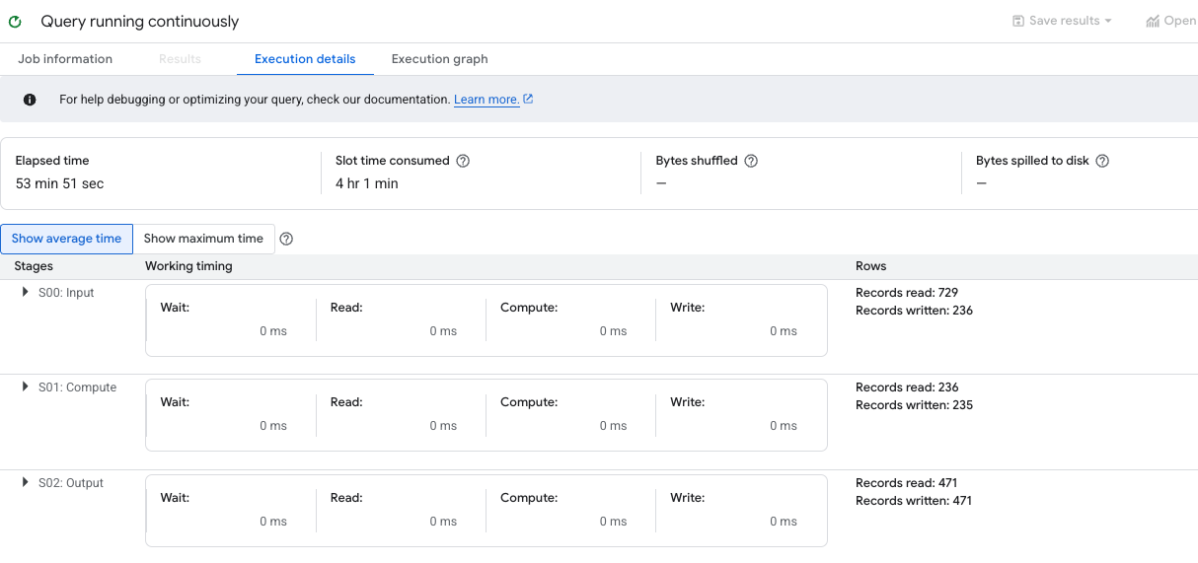

Query the unsportsmanlike_messages table
- In the explorer, expand your project and select the esports_analytics dataset.
- Click the plus to create a new query.
- In the query tab provided, enter the following query.
- SELECT * FROM `set at lab start.esports_analytics.unsportsmanlike_messages` LIMIT 1000
- Copied!
- Run the query. This time you see only the unsportsmanlike_messages displayed.

Create the EXPORT DATA to Bigtable continuous query
- Click the plus to create a new query.
- In the query tab provided, enter the following query.
EXPORT DATA
OPTIONS (
format = 'CLOUD_BIGTABLE',
auto_create_column_families=TRUE,
uri = 'https://bigtable.googleapis.com/projects/set at lab start/instances/instance/tables/unsportsmanlike'
)
AS
SELECT
user_id AS rowkey,
message_text,
timestamp
FROM
- APPENDS(TABLE `esports_analytics.unsportsmanlike_messages`)
- Copied!
- Click More.
- Choose the Continuous query mode option.
- Run the query.
You will see an error like the one below:
- Bigtable app profile must be configured with LOW priority to run the export job. Current app profile: 'default' has priority: 'PRIORITY_HIGH'. Please refer to https://cloud.google.com/bigtable/docs/request-priorities on how to configure the app profile priority.
- You can resolve this error with the steps below.

Set the Bigtable application profile to low
- Search for and access Bigtable at the top of the console.
- Click on the Instance ID, on the Bigtable Overview page, choose Application Profiles. The default application profile is displayed.
- Choose Edit Application Profile. Click the Edit application profile pencil within the default Application profile ID.
- For Select a routing priority, choose Low.
- Click Save.
- Return to BigQuery on the Query tab for EXPORT DATA.
- Run the query.
You see the time running for the query. It will run indefinitely as it is continuous.

Check the records processed by the EXPORT DATA Continuously running query
- Below the query, you see Job information and two tabs, Execution details and Execution Graph. The active tab is Execution details. Wait 1 to 2 minutes for the stages column to update with the first stage and click Execution Graph.
The result is that you see the number of records currently processed.
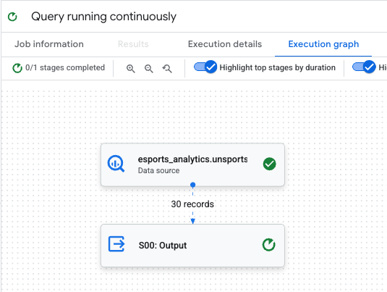
This means records are pulled from the unsportsmanlike_messages table in BigQuery and stored in the Bigtable table messages within your instance.
Alternatively you can use the cbt Cloud Shell command below to query the unsportsmanlike table in Bigtable.
- cbt -instance instance read unsportsmanlike count=10
- Copied!
- If you see records displayed without an error message in Cloud Shell, this confirms the continuous query to write the records to Bigtable is working.

Time to reflect
Using your journal, answer the following questions:
- Considering your data and use cases, how might you use continuous queries in your workflow?
- Note: With this lab you learned two ways to use continuous queries, updating records in one table based upon new records in another, and exporting the data for these change to Bigtable for fast retrieval with your app. These are not the only use cases for continuous queries, please refer to Create continuous queries within the BigQuery documentation for more information.
Click Check my progress to verify the objective.
Verify the results in BigQuery.

Task 9. Monitor messages with your streamlit application
In this task, you will access Cloud Shell, create and activate a Python 3 virtual environment, and then edit and run your app.py file. This will allow you to experience moderating unsportsmanlike messages, now that Bigtable has been populated with unsportsmanlike chat message records.

Review app.py for your project
- Return to Cloud Shell terminal.
- Confirm you are in the home directory.
- cd ~
- Copied!
- Navigate to the esports directory.
- cd esports
- Copied!
- Open the Cloud Shell Editor.
- Open the app.py file.
- Review the file.
At a high level the Python script app.py is a web application built using the Streamlit framework. Its primary purpose is to serve as a moderation dashboard for an esports platform. The application connects to a Google Cloud Bigtable database, fetches chat messages that have been flagged for "unsportsmanlike" conduct, and displays them in an interactive interface for a human moderator to review and take action on.

Create and activate your Python 3 virtual environment
- Return to the Cloud Shell terminal. Make sure you are in the ~/esports directory.
- Run the following command to create and activate the Python 3 virtual environment.
python3 -m venv gemini-streamlit
source gemini-streamlit/bin/activate
- pip install -r requirements.txt
- Copied!
- Note: The `requirements.txt` file will install both the streamlit and Bigtable Python libraries so that you can use these with app.py.

Run your application
- Run the following command to run and deploy the application.
streamlit run app.py \
--browser.serverAddress=localhost \
--server.enableCORS=false \
--server.enableXsrfProtection=false \
- --server.port 8080
- Copied!
- You see the following output:
- Collecting usage statistics. To deactivate, set browser.gatherUsageStats to false. You can now view your Streamlit app in your browser. URL: http://localhost:8080
- This means that the application is now loaded.
- Click URL http://localhost:8080 to access the application and moderate the chat messages. Feel free to experiment with the application including testing the Suspend User, Ban User, and Dismiss as False Positive features.
- Note: These features are included just to simulate the application and are included to illustrate a Proof of Concept. In a real world environment these would communicate with the actual game to take action as needed based upon a human being reviewing the chat messages.

Time to reflect
Using your journal, answer the following questions:
- Considering your data and use cases, how might you use Streamlit to serve applications for your customers?

Congratulations!
You used Streamlit to monitor and moderate chat messages within an esports gaming environment. You also created cloud resources to support this solution, generated synthetic chat message data, collected these messages with Pub/Sub and BigQuery. Then you filtered the messages with BigQuery and sent the filtered messages to Bigtable. Finally, you created an application for chat moderators with Streamlit, so that they may review the messages and take the appropriate action.

Next steps / learn more
- Generate a SQL query
- Explain SQL queries
- Gemini Models
- Generative AI
- Write better prompts for Gemini for Google Cloud

Google Cloud training and certification
...helps you make the most of Google Cloud technologies. Our classes include technical skills and best practices to help you get up to speed quickly and continue your learning journey. We offer fundamental to advanced level training, with on-demand, live, and virtual options to suit your busy schedule. Certifications help you validate and prove your skill and expertise in Google Cloud technologies.
Manual last updated on December 02, 2025
Lab last tested on December 02, 2025
Copyright 2025 Google LLC. All rights reserved. Google and the Google logo are trademarks of Google LLC. All other company and product names may be trademarks of the respective companies with which they are associated.

